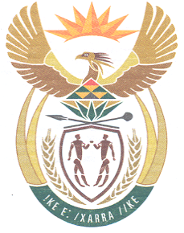
South African High Commission
Wellington, New Zealand

Dear Applicant

APPLICATION FOR SA UNABRIDGED DEATH CERTIFICATE

Thank you for your inquiry regarding the application for an unabridged birth certificate.

Please note that all forms must be completed in black ink

Requirements

1. DHA-132 form Application for an unabridged death certificate

2. Self-addressed track and trace courier bag in which the printed document will be couriered to you on receipt from DHA.

3. Fees NZ$ 10.00 per application
Payments can be made via online bank transfer.

Please ensure to do a SEPARATE transfer for each application.
Attach proof of payment for each individual application.

Bank Account Details
South African High Commission DHA
12-3140-0362170-00

Particulars – Type of application (eg. Adult passport, Unabridged Birth Certificate etc.)
Code – First Name (Name of applicant)
Reference – Surname (Of applicant)

4. A certified copy of any previous certificate/s issued should be included to facilitate the location of these records.

5. Courier completed application form and required documents for forwarding by diplomatic bag to the DHA to:

SAHC
PO Box 25406
Wellington
6140

Processing time is approximately 1 year, maybe longer.

Please note that the South African authorities will only process applications completed IN FULL DETAIL

Regards

Consular Section
Tel number 04 815 8484

