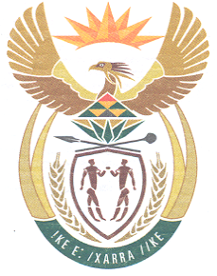
South African High Commission
Wellington, New Zealand

Dear Applicant

APPLICTION FOR A SA UNABRIDGED MARRIAGE CERTIFICATE

Thank you for your enquiry apply for an unabridged marriage certificate.

Please visit the link provided, http://www.dirco.gov.za/Wellington/ (under certificates) to download the marriage certificate application BI-130.

Please ensure that all forms are completed in black ink

Requirements

- BI-130 form Application for a SA unabridged marriage certificate.

- Certified copy of your passport or SA id or copy of the certificate if you have this (optional). This may help speed up your application.

- Self-addressed track and trace courier bag per application to courier printed document on receipt from DHA.

- Fee NZ$10.00 per application
Payments can be made via online transfer payable to the SA High Commission.

Please ensure to do a SEPARATE transfer for each application.
Attach proof of payment for each individual application.
Bank Account Details
South African High Commission DHA
12-3140-0362170-00
Particulars – Type of application (eg. Adult passport, Unabridged Birth Certificate etc.)
Code – First Name (Name of applicant)
Reference – Surname (Of applicant)

- A copy of any previous certificate/s issued should be included to speed the location of the records.

All completed applications can be forwarded to the below address:
SAHC
PO Box 25406
Wellington
6140

Processing time is approximately 1 year, maybe longer.
Please note that the South African authorities will only process those applications completed in full.

Regards

Consular Services

Tel number 04 815 8484

