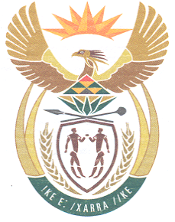
South African High Commission
Wellington, New Zealand

Dear Applicant

SA UNABRIDGED BIRTH CERTIFICATE

Thank you for your inquiry regarding an application for a SA unabridged birth certificate.

Please complete below documentation and post/courier to the South African High Commission in Wellington. This office will forward your application to South Africa for processing.

Please ensure that all forms are completed in black ink

Requirements

1. BI-154 form

2. DHA-154 form Application for a birth certificate

3. Certified copy of your passport or SA id document or certified copy of the certificate if you have this (optional). This may help speed up your application.

4. Fee NZ$10.00 per application
Payment can be made via online bank transfer.

Please ensure to do a SEPARATE transfer for each application.
Attach proof of payment for each individual application.

Bank Account Details
South African High Commission DHA
12-3140-0362170-00

Particulars – Type of application (eg. Adult passport, Unabridged Birth Certificate etc.)
Code – First Name (Name of applicant)
Reference – Surname (Of applicant)

5. Self-addressed track and trace courier bag per application for forwarding printed document/s received from DHA.

6. Certified copy/ies of any previous birth certificate/s issued should be included to facilitate the tracing and processing of the record.

All completed applications can be forwarded to the below address:

PO Box 25406
Featherston St
Wellington
6140

Processing time is approximately 1 year, maybe longer.

Please note The South African authorities will only process those applications completed IN FULL DETAIL. Identity number or birth entry number must be supplied where possible.

Birth records date back only to the year 1901.

Regards

Consular Services
Tel Number 04 815 8484

