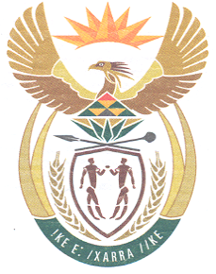

**South African High Commission**

**Wellington, New Zealand**

Dear Applicant

**RENUNCIATION OF SOUTH AFRICAN CITIZENSHIP**

The Citizenship legislation, effected on 6 October 1995 (Act 88 of 1995) provides for South African citizens to voluntarily apply to renounce their South African Citizenship. To be eligible, applicants must have already obtained the citizenship of another country due to the effect of renouncing—the person cannot be stateless.

South Africans over eighteen years of age, who voluntarily apply for foreign citizenship must first have their retention of South African citizenship *confirmed* before taking up citizenship of another country. Failure to do so will result in the automatic loss of South African citizenship. Such persons must still inform South Africa of their actions, either by way of formal renunciation or by a confirmation of their status so that loss of citizenship can be recorded.

**PLEASE ENSURE ALL FORMS ARE DONE IN BLACK INK**

**Renunciation check list**

1. Two copies of form BI-246 per applicant.
2. Form BI-529.

Details of your present status in order that we may ascertain your claim for South African citizenship. Information pertaining to parent's details; minimum of their full date and place of birth is required.

1. Certified copy of the Citizenship certificate of the other nationality that you now hold.
2. Certified copy of your South African Birth Certificate (if applicable).
3. ORIGINAL
   * South African Passports
   * Identity Documents
   * Retention of South African Citizenship certificate (if applicable)
   * South African Naturalization certificate (if applicable).

NOTE: These documents will NOT BE RETURNED TO YOU but will be sent to the Department of Home Affairs in South Africa for record purposes and eventually be destroyed.

1. ***Return prepaid courier bag (self-addressed)***

**The courier bag must be track and trace and this will be used to return the issued passport/document on receipt of DHA from Wellington.**

1. There is no fee to be paid for this application.

Please note that processing of applications take between 9 - 12 months.

Applications are forwarded to the DHA in Pretoria, South Africa for processing.

Regards

Consular Services

Tel No 04 815 8484